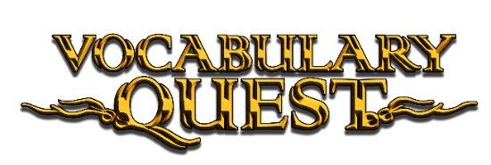

Why Direct Vocabulary Instruction?

The significance of direct vocabulary instruction in enhancing reading comprehension is well-documented, highlighting its critical role in developing essential skills in vocabulary and reasoning [1]. Renowned researchers and educators like Dr. Robert Marzano, Isabel L. Beck, and Margaret G. McKeown are strong advocates for this instructional approach. Research demonstrates that direct vocabulary instruction substantially improves reading comprehension, with students receiving explicit instruction outperforming others in understanding and applying new words [2]. The effectiveness of this approach is evident in its strong correlation with enhanced text comprehension [3]. However, the implementation of direct vocabulary instruction faces notable challenges. Teachers often find it time-intensive to prepare effective lessons that engage students consistently. Moreover, maintaining student interest can be difficult, as traditional methods may not always captivate young learners, impacting their motivation and ability to retain new vocabulary.

What is Vocabulary Quest?  
Vocabulary Quest addresses traditional vocabulary teaching challenges with a game-based direct learning program for middle and high school students needing reading support. Available through web browsers on desktop and laptop computers, it merges proven learning strategies—such as those discussed by educational researcher Dr. Marzano—with an immersive gaming environment featuring over 1,000 academic vocabulary words.

Designed as a flexible intervention plan, Vocabulary Quest provides structured, grade-specific vocabulary instruction requiring just **15 to 30 minutes per week**, totaling approximately 9 to 18 hours per school year. The program outlined here is specifically tailored for middle school:

* **6th Grade**: Focuses on 300 vocabulary words from 3rd–5th grade, helping students rebuild foundational vocabulary and close early reading gaps.
* **7th Grade**: Covers 300 words from 6th–8th grade, bringing students up to grade-level vocabulary and reinforcing essential academic terms.
* **8th Grade**: Introduces 400 advanced words from 9th–12th grade, preparing students for high school-level vocabulary and boosting reading confidence.

Its self-paced structure allows students to engage with content at school or at home, reducing the need for direct teacher intervention and saving valuable instructional time. A built-in Learning Management System (LMS) enables educators to efficiently track student progress.

Set in the enchanting Lands of Vocab, players embark on a mission to restore a world drained of environmental energy by rogue mages—using their growing vocabulary as a tool for success. By blending engaging gameplay with evidence-based instruction, Vocabulary Quest makes vocabulary acquisition more effective, enjoyable, and accessible for a diverse range of learners.

About the Vocabulary Quest Word List:

Vocabulary Quest incorporates the three tiers of vocabulary development, a framework that categorizes words into distinct levels based on their frequency of use and significance for comprehension and strongly supported by both Beck and Marzano [14][4]. The tiers are as follows:

1. **Tier 1: Basic Vocabulary**
   * Comprising everyday words commonly used in oral language, Tier 1 consists of 40 words acquired through routine conversation and daily experiences. These words serve as a warm-up to the gameplay.
2. **Tier 2: High-Frequency Words**
   * More sophisticated than Tier 1, these words are crucial for grasping and expressing complex ideas found in written texts. There are 960 Tier 2 words, forming the main focus of Vocabulary Quest.
3. **Tier 3: Low-Frequency, Domain-Specific Words**
   * Specialized words tied to specific subjects, Tier 3 vocabulary (120 words) is contextualized within relevant subject matter and will expand in future updates.

The majority of the Tier 2 vocabulary words were curated from lists recommended by independent school districts, such as Hyde Park Central, Berkeley Unified, and Southern Cayuga Central School Districts. For Tier 1 and Tier 3, The New Academic Word List (NAWL), the New General Service List (NGSL), and Dr. Marzano’s recommended word lists were used [15]. Vocabulary Quest’s comprehensive word list not only prepares players for the challenges within the game but also aligns with the vocabulary expectations of standardized exams such as the SAT/ACT and Common Core standards, ensuring a holistic and valuable learning experience. The entire Vocabulary Quest list can be found at the bottom of this document.

**Learning Strategies Utilized**

Descriptive Explanations

Descriptive explanations that clarify a word’s meaning, usage, and nuances have been shown to significantly boost vocabulary acquisition [4]. Supported by researchers like Dr. Marzano [16], this approach is central to Vocabulary Quest. The program presents each word with a rich descriptive explanation, paired with definitions, usage examples, and audio support—including pronunciation—to reinforce understanding and retention.

Dual-Coding

According to the dual-coding theory, combining verbal and visual information significantly boosts learning and memory by engaging both textual and graphical representations [5]. Vocabulary Quest exemplifies this approach, dual-coding each word with a corresponding entertaining illustration, thereby facilitating a deeper understanding and retention of vocabulary.

Pre-Instruction

Research shows pre-teaching vocabulary boosts comprehension and acquisition, with students learning pre-taught words outperforming others [6][7]. Vocabulary Quest employs this approach by introducing words in five-word sets, contextualized in a fantasy narrative within the immersive Lands of Vocab. This method is enhanced with dual-coded illustrations, integrating verbal and visual learning to deepen understanding.

Repetition  
The significance of repeated exposure to vocabulary words through diverse methods is crucial for effective learning, highlighting the necessity of interacting with new vocabulary in various contexts to boost retention and comprehension [8-11]. Vocabulary Quest complements its fantasy passages with over 7 games, such as multiple choice, matching, fill in the blank, and crossword puzzles, offering ample opportunities for repeated exposure to the words being learned and thereby reinforcing learning.

Spaced Repetition

Spaced repetition, a technique shown to significantly improve learning outcomes, plays a crucial role in Vocabulary Quest. The game thoughtfully applies spaced repetition by reintroducing fantasy passages at various intervals throughout a student's progression. Moreover, it features a dedicated quiz game that randomly selects 10 words from a pool of 100, employing the principles of spaced repetition to strengthen and boost vocabulary retention [12].

Track Troubled Words

Vocabulary Quest will place red dots next to words in quizzes that students answered incorrectly. These words can be studied separately from the main game. If students wish, they can create custom lists and add new vocabulary words to use in various games.

Gamification

Gamification, recognized as an effective strategy to enhance student engagement and motivation, thereby improving learning outcomes, incorporates game elements into educational settings [13]. Vocabulary Quest leverages this approach to captivate learners by allowing them to progress through levels by defeating opponents in quizzes. Players have the option to select avatars, earn medals, join guilds, unlock new equipment, and gain special abilities, enriching their learning experience with increased motivation and retention through interactive gameplay.

Conclusion

Vocabulary Quest introduces a progressive approach to vocabulary learning, combining direct instruction with engaging gameplay and effective learning strategies. It boosts vocabulary acquisition and reading comprehension for middle and high school students in need of reading support, offering time-saving benefits for teachers and enhancing student engagement. Schools and districts benefit from improved test scores and pass rates, potentially leading to better funding and resource allocation. Vocabulary Quest represents a comprehensive educational tool that addresses the needs of students, educators, and school systems, marking a significant step forward in vocabulary education.

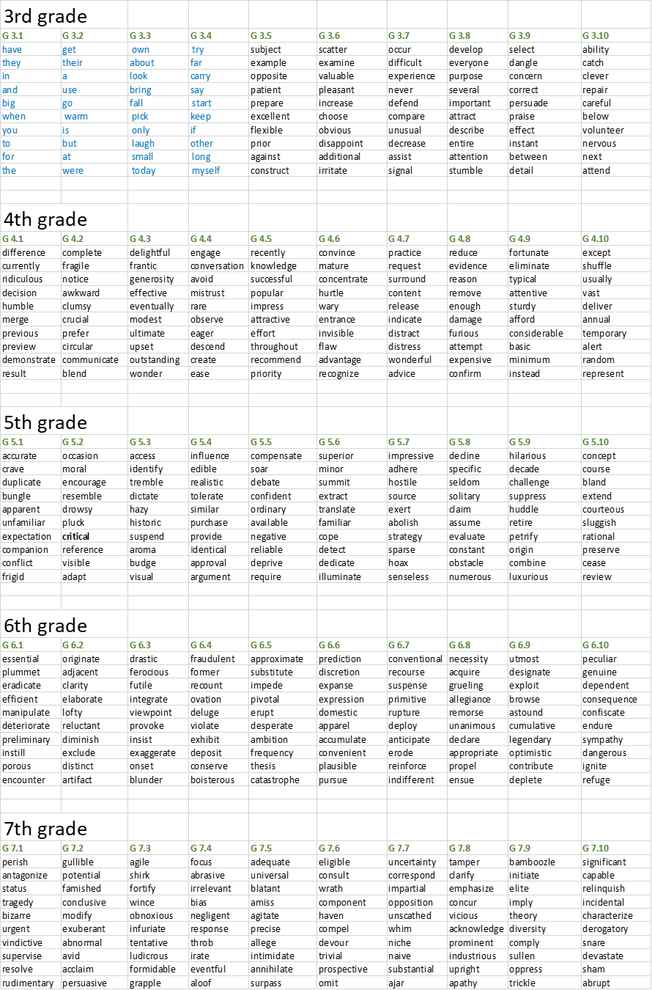





**References**

1. National Reading Panel (2000). *Report of the National Reading Panel*.
2. Beck, I. L., Perfetti, C. A., & McKeown, M. G. (1982). *Effects of long-term vocabulary instruction on lexical access and reading comprehension*. Journal of Educational Psychology.
3. McKeown, M. G., Beck, I. L., Omanson, R. C., & Perfetti, C. A. (1983). *A study of the effects of vocabulary instruction on reading comprehension*. Reading Research Quarterly.
4. Beck, I., McKeown, M., & Kucan, L. (2002). *Bringing Words to Life: Robust Vocabulary Instruction*.
5. Paivio, A., & Desrochers, A. (1981). *Dual-coding theory: Cognitive and psychological bases of dual coding*.
6. Brett, A., Rothlein, L., & Hurley, M. (1996). *Vocabulary acquisition from listening to stories and explanations of target words*. The Elementary School Journal.
7. Carney, R. N., Anderson, D., Blackburn, C., & Blessing, D. (1984). *Preteaching vocabulary and the comprehension of social studies materials by elementary school children*. Social Education.
8. Senechal, M. (1997). *The differential effect of storybook reading on preschoolers' acquisition of expressive and receptive vocabulary*. Journal of Child Language.
9. Leung, C. B. (1992). *Effects of word-related variables on vocabulary growth through repeated read-aloud events*.
10. Daniels, P. T. (1994, 1996). *Repeated exposure to vocabulary in different contexts*.
11. Dole, J. A., Sloan, C., & Trathen, W. (1995). *Teaching vocabulary within the context of literature*. Journal of Reading.
12. Dunlosky, J., Rawson, K. A., Marsh, E. J., Nathan, M. J., & Willingham, D. T. (2013). *Improving Students’ Learning With Effective Learning Techniques: Promising Directions From Cognitive and Educational Psychology*. Psychological Science in the Public Interest.
13. Deterding, S., Dixon, D., Khaled, R., & Nacke, L. (2011). *Gamification: Using Game Design Elements in Non-Gaming Contexts*. Journal of Interactive Learning Research.
14. Robert J. Marzano (2020). Teaching Basic, Advanced, and Academic Vocabulary
15. Robert J. Marzano, Debra J. Pickering (2005). Building Academic Vocabulary Teacher’s Manual
16. Robert J. Marzano, Julia A Simms (2011). Vocabulary for the Common Core